1. Introduction

The purpose of this report is to put forward a proposal to fulfill the requests of our client, Ms. Kaia Nightingale. She has requested an electrical assist *recumbent* tricycle that will be primarily powered by the driver’s peddling, shown in Figure 1.

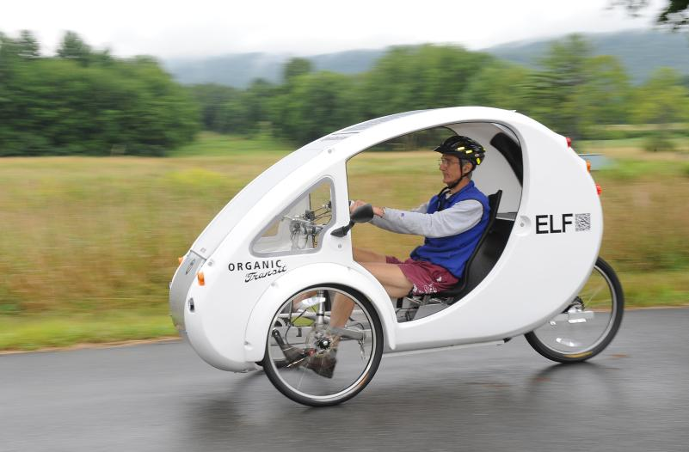

Figure : Recumbent Tricycle1

My group and I will be working on the body of the project, which will be explained further on in this report. Our goal is to develop our aspect to the desires and standard of quality of our client to ensure a safe and efficient final design.

1. Background

Ms. Kaia Nightingale has put in a proposal to develop, design, and produce an electric assist recumbent tricycle that will be fully enclosed to allow for winter commuting and be able to drive along with road traffic in either the bike lane or driving lanes.2 The electrically assisted tricycle, herein referred to as the Vehicle, will be primarily operated by the operator’s *mechanical energy*. The electric motor will allow for longer commutes and the possibility of traversing over difficult terrain, i.e. hills, unpaved surfaces.

My group and I will be working on the body of the Vehicle. This involves the development of the size and shape of the outer shell that will enclose the Vehicle, the material or materials that will be used to make the outer shell, the frame, the positioning of interior devices (seat, wheel, mirrors, climate control), and locking mechanisms.

1. Project Description
   1. Size and Shape of Shell

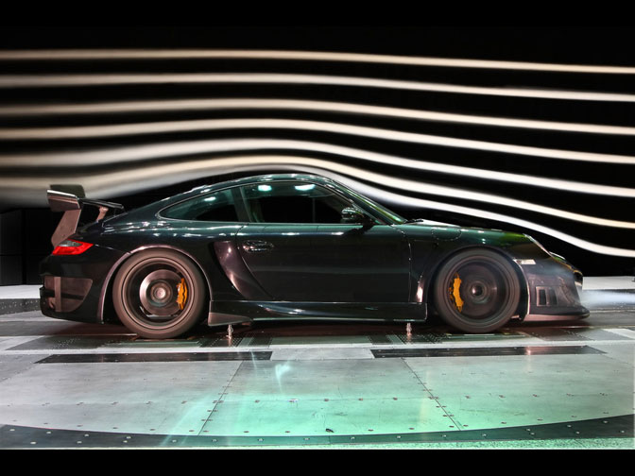Mr. Douglas Raymond is the lead designer for the outer shell in respect of shape and size. Size is an important aspect of the whole Vehicle. An important engineering principle is the efficiency of the use of this space such as how to allocate all necessary components, such as the electric motor in relation to where the operator sits. In such a small vehicle there can be no wasted space. Another principle being considered in this aspect is the *aerodynamics* of the outer shell and how it affects the overall *aesthetics*.

Figure : Aerodynamics3

Figure : Aerodynamics

* 1. Materials of Outer Shell

The materials of the outer shell will depend upon the overall strength of the material and how much weight it will add to the Vehicle. Mr. Nick Kamarianakis will be leading up the design for the materials. The strength of the material will have to be able to provide the operator the sense of security that if a larger vehicle hits the Vehicle, he will survive the collision. However the weight of the chosen material has to be light enough that the operator can still peddle the Vehicle to work and back again every day.

* 1. Frame

The frame of the Vehicle is its skeleton. It will hold up all that is above it and provide strength to the overall Vehicle. Mr. Jacob Hawley is the lead designer for this aspect. Important engineering principles leading his design decisions are *centre of gravity* and *force distribution*. These are important for the location of tires and frame dimensions to support the driver and the Vehicle itself, while keeping the Vehicle balanced.

* 1. Interior

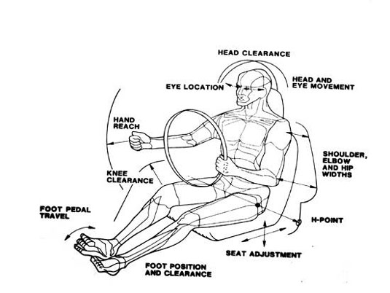The operator of the Vehicle will need various devices to operate the vehicle. These range from where and how the operator will sit, to mirrors so the operator may see behind him. I, Will Rose, will be leading the design of the interior. My main engineering principles are *ergonomics* and *adaptability*. The operator must feel comfortable while operating the Vehicle so the commute can be made without strenuous effort and with enjoyment of driving the Vehicle. The adaptability of those devices, shown in Figure 3, will allow the operator to make himself comfortable and increase the commercial success of the Vehicle.

Figure 3: Adaptability4

* 1. Locking Mechanism

Mr. Neal Traynor is leading the design of the locks for the Vehicle. Important engineering principles for the locking systems are *durability*, *simplicity*, and *effectiveness*. These combined will allow the Vehicle to be safely secured when not in use and give the owner peace of mind that his Vehicle will remain where he left it.

1. Project Timeline

The project will be developed over a period of time to ease the design process. See Appendix A for details.

1. Team Contract

To ensure that the client’s standard of quality is met, the group has ensured its commitment by writing up a team contract. To review the contract in its entirety, please refer to Appendix B.

1. Conclusion

The goal of this report to is to clearly present the group’s proposal to design and develop a body for the Vehicle that will conform to the wishes of the client. Each component of the body is described herein and the leading designer for that component. If there are any comments, questions, or concerns please contact the undersigned for inquiry.

Will Rose, Interior. Contact: [willrose@cmail.carleton.ca](mailto:willrose@cmail.carleton.ca)

Neal Traynor, Locking. Contact:

Nick Kamarianakis, Shell Materials. Contact:

Douglas Raymond, Shell Shape. Contact:

Jake Hawley, Frame. Contact:

**Glossary**

Adaptability: To move or change certain features to the desire of the operator.

Aerodynamics: The relationship of the Vehicle moving through air.

Aesthetics: How the Vehicle looks to other people.

Centre of Gravity: Location on the frame where the weight of the Vehicle can be analyzed.

Durability: Withstand constant use without fail.

Effectiveness: To perform desired function as intended.

Ergonomics: The relationship between the driver and the Vehicle.

Force Distribution: How the weight of the Vehicle is spread over the frame.

Mechanical Energy: The operator transferring his energy into motion of the Vehicle by peddling.

Recumbent: Lying down. In the case of the Vehicle, the operator peddles the vehicle in a seated position

Simplicity: Without complexity.

References

1. Richie Davis. (2013 July 26). *The Recorder*. [Online]. Available: <http://www.recorder.com/home/7815623-95/new-way-to-go>
2. Kaia Nightingale. :Electric Vehicle Design”. Presented at CCDP 2100I, Ottawa, ON, 2013.
3. Unknown. [Online]. Available: <http://forums.anandtech.com/archive/index.php/t-311737.html>Dr. Sougata Karmarkar. *Basic Ergonomics in Automotive design.* [Online] Available: <http://www.dsource.in/course/ergonomics/auto-ergo/introduction/introduction.html>

A. Team Timeline

|  |  |
| --- | --- |
| **Date** | **Description** |
| Oct 7th 2013 | Presentation of preliminary findings |
| Oct 14th 2013 | Preliminary Report due |
| Oct 21st 2013 | Status Presentation |
| Nov 11th 2013 | Report of findings |
| Nov 18th 2013 | Presentation of findings |

**The team meets every Sunday at 2pm for 2 hours to organize ideas and deliverables to plan for following classes

B. Team Contract

1. Roles and Associated Responsibilities
   1. Team Leader

Group Member: Will Rose

Responsibilities:

1. Assignment Aggregation.
2. Quality Control
3. Arbitration
4. Schedule Group Meetings
   1. Team Liason

Group Member: Douglas Raymond

Responsibilities:

1. Inter-group communication
2. Facilitate inter-group meetings to coordinate related research.
   1. Team Minuteman

Group Member: Nick Kamarianakis

Responsibilities:

1. Record Keeping.
2. Record discussions and meetings
3. Participation
   1. All tem members will participate equally for team projects (assignments where there are team marks) and presentations
   2. There will be no substitution of work or responsibilities that relate to the fulfillment of assignments
   3. Where there is a conflict or uneven distribution of work, Team Leader will allocate and arbitrate as necessary.
   4. Failure to participate, for any reason, or not participate to the standard of quality equally, see Section 4.1, will result in the guilty party receiving additional work in equal quantity of unparticipated amount or removal from the group if guilty party is deemed detrimental and hazardous to group quality.
   5. All members will attend group meetings.
   6. Group meetings will be liquid. All meeting times will coordinate with group member schedules. See Section 3.1.
4. Decision-Making
   1. Group decisions will be made by unanimous consensus.
   2. No action will be taken without full team forewarning, discussion, and consensus.
   3. Where conflict exists in the decisions of an action, Team Leader will arbitrate.
5. Assignment Quality and Guidelines
   1. All minimum standards set out in course outline and term package will be met.
   2. Where there exists a group submission
      1. Individual member submissions will be collected by Team Leader to aggregated into one submission
      2. Team member submissions will be submitted to Team Leader at a reasonable date before the due date of the assignment. See Section 3.1.
      3. Member submissions will adhere to the minimum standards herein stated. See Section 4.1.
      4. Failure to submit component will result in consequences stated in Section 2.4.
   3. Research sources will be cited in IEEE format set out in the term package.

If you accept the terms and agreements herein stated, sign underneath:

Name Signed Date

Project Proposal

Final Draft

CCDP 2100 I

Will Rose

100800974

Ms. Janet Hempstead

October 7, 2013